|  |  |  |  |
| --- | --- | --- | --- |
| Exp.No | 2 | Name | APARNAA.M |
| Date | 27.07.2021 | Roll No | 19ITR008 |
| Title | Design a website using stylesheets | | |

**Aim:**

To design a webpage using HTML and CSS

|  |  |  |
| --- | --- | --- |
| S No | CSS Property | Description |
| 1 | background-color | specifies the background color of an element |
| 2 | opacity | specifies the opacity/transparency of an element |
| 3 | background-image | specifies an image to use as the background of an element |
| 4 | background-repeat | To repeat an image vertically |
| 5 | background-position | specify the position of the background image |
| 6 | background-  attachment | specifies whether the background image should scroll or be fixed |
| 7 | border-style | specifies what kind of border to display |
| 8 | border-width | specifies the width of the four borders |
| 9 | border-color | used to set the color of the four borders |
| 10 | margin | used to create space around elements, outside of any defined borders |
| 11 | padding | create space around an element's content, inside of any defined borders |
| 12 | height and width | used to set the height and width of an element |
| 13 | font-family | to specify the font of a text |
| 14 | position | specifies the type of positioning method used for an element |
| 15 | display | specifies if/how an element is displayed |
| 16 | display:inline-block | display list items horizontally instead of vertically |
| 17 | margin:auto | To horizontally center a block element |
| 18 | text-align:center | center the text inside an element |
| 19 | position:absolute | for aligning elements |
| 20 | list-style-type | Style of displaying list items icons |

**CODE:**

<html>

<style>

form {

background-color: whitesmoke;

width: 450px;

height: 400px;

border: 1px solid;

padding: 80px 40px;

margin: 20px;

border-radius: 30px;

}

label {

font-size: 18px;

min-width: 200px;

}

.button1 {

background-color: rgb(37, 247, 236);

padding: 5px 28px;

border-radius: 10px;

}

.button1:hover {

background-color: teal;

color: white;

}

.button2 {

background-color: rgb(37, 247, 236);

padding: 5px 28px;

border-radius: 10px;

}

.button2:hover {

background-color: teal;

color: white;

}

</style>

<body style="background-color: lightblue;">

<div align="center"><img src="image/logo1.jpeg" width="50%" height="100"></div>

<div style="padding:100px 450px 20px;">

<form>

<div style="border-bottom: 3px solid lightskyblue; text-align:center; font-size: 20px; font-weight: bold;">

New Registration</div>

<div style="justify-item:center;">

<label for="name" style="font-size: 18px;" style="maxwidth:30%"><br>NAME:<span

style="color:red;">*</span></label>

<span style="padding-inline:82px;">

<input style="margin-right:50px;" type="text" placeholder="Enter your Name" name="name" required>

</div></span><br>

<div style="justify-item:center;">

<label for="Acc no." style="font-size: 18px;"><br>Account Number:<span

style="color:red;">*</span></label>

<span style="padding-inline:11px;">

<input type="text" placeholder="Enter Account No." name="Acc no." required>

</div></span><br>

<div style="justify-tem:center; maxwidth:30%">

<label for="mailid" style="font-size: 18px;"><br>E-mail:<span style="color:red;">*</span></label>

<span style="padding-inline:89px;">

<input type="email" placeholder="Enter your mail id" name="E-mail" required>

</div></span><br>

<div style="justify-item:center;">

<label for="Password" style="font-size: 18px;"><br>New Password:<span

style="color:red;">*</span></label>

<span style="padding-inline:32px;">

<input type="password" placeholder="Password" name="psw" minlength="8" required>

</div></span><br>

<div style="justify-item:center;">

<label for="Password" style="font-size: 18px;"><br>Confirm Password:<span

style="color:red;">*</span></label>

<span style="padding-inline:8px;">

<input type="password" placeholder="Password" name="psw" minlength="8" required>

</div></span><br>

<span style="padding-inline:80px;">

<button class="button1">Submit</button></span>

<button class="button2">Reset</button>

</form>

</div>

<footer

style="padding: 20px 0;padding-left: 100px;font-size: 15px; background-color:lightgray;border-radius: 12px;">

<h4>New Registration</h4>

<h4>Term and Conditions</h4>

<p>The Terms mentioned herein form the contract between the User using the Internet Banking services and the

Bank. By applying for Internet Banking Services through all modes of registration available to the users and

accessing the service the User acknowledges and accepts these Terms of Service (Terms & Conditions). All the

services/ products purported to be offered hereunder will be denominated in Indian currency. Notwithstanding

anything contained herein, all terms and conditions stipulated by the bank pertaining to the accounts shall

continue to be applicable to the users provided in the event of a conflict in the terms stipulated by the

bank and the terms herein, the terms herein shall have overriding effect. These terms will be in addition to

and not in derogation of the terms and conditions relating to any account of the user. The agreement shall

remain valid until it is replaced by another agreement or terminated by either party or account is closed,

whichever is earlier.</p>

</footer>

</body>

</html>

**OUTPUT:**

Homepage:

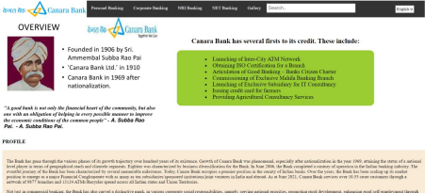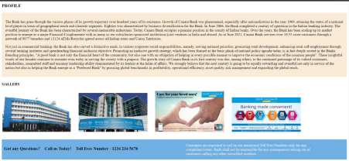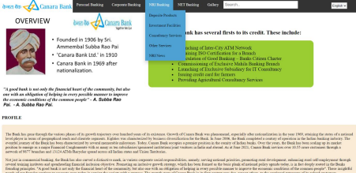First page:

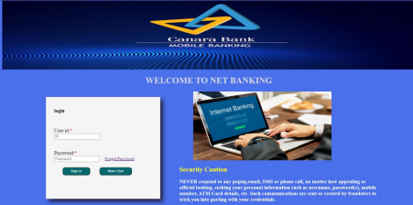

Second page:

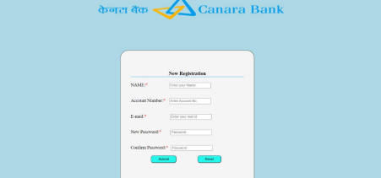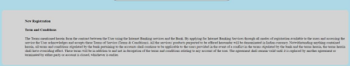

**RESULT:**

Thus the attractive web page is designed successfully using style sheets.

|  |  |  |  |
| --- | --- | --- | --- |
| **S.no** | **Split-up** | **Max Mark** | **Awarded Mark** |
| **1** | **COE** | **20** |  |
| **2** | **RECORD** | **20** |  |
| **3** | **VIVA** | **10** |  |
| **4** | **TOTAL** | **50** |  |